**15.Design TM using simulator to accept the input string anbn**

**AIM:** To design TM using a simulator to accept the input string anbn.

**TRANSITION DIAGRAM:**

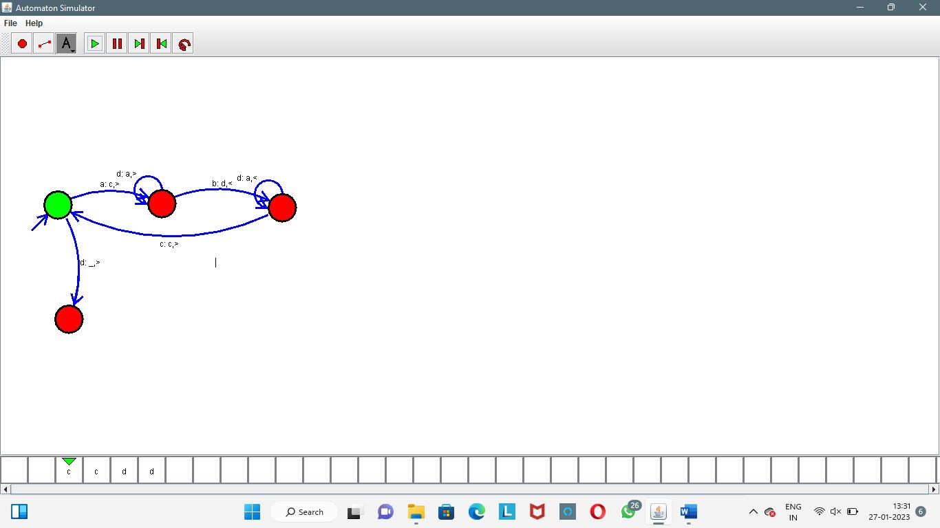

**RESULT:** The TM is designed to compute the string given as input using a simulator.